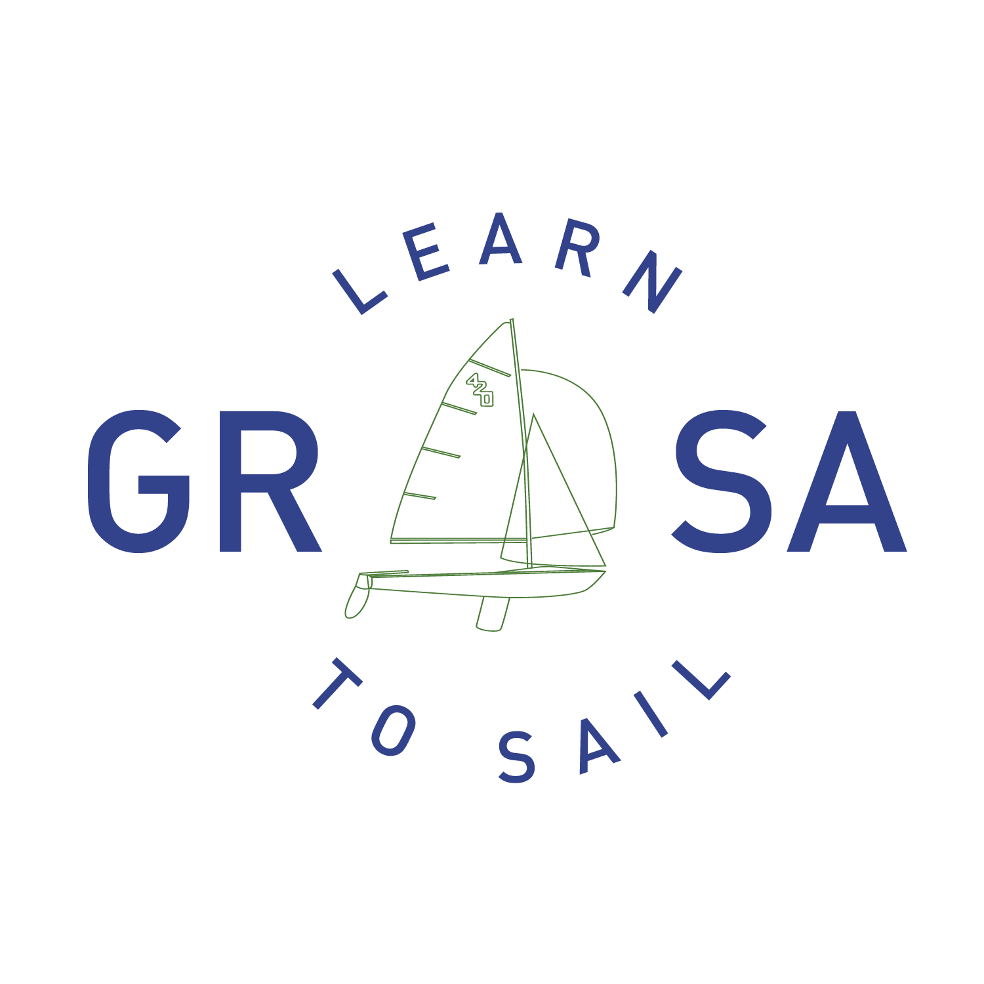
Student Handbook

Objectives of the Program:
- Promote the sport of sailing and provide outreach to the surrounding community.
- Provide an invaluable resource to the growth of the club through fostering the sport through learn to sail programs.
- Instill the love of sailing to our students and make every sailor we work with a better sailor.
The Greater Richmond Sailing Association is a membership organization whose purpose is to promote sailing in the Richmond, Virginia area.

Covid-19:
GRSA is dedicated to helping prevent the spread of Covid-19 and maintaining a safe learning environment for all students and staff. There is an entire section of this handbook dedicated to our procedures and protocols. It is the last section of this document and is extremely important to carefully review and prepare ahead of the course for. The required forms for attending the class will include a signature of acknowledgement of these protocols.

The Staff:
All Sail Programs staff members are US Sailing Certified. This means they have been trained and are backed by the governing body of Sailing in the United States. Any staff member over the age of 18 has completed a background check and is a certified coach through Chesterfield County. There will be adequate instructor staffing to assure an optimum student/teacher ratio. The lead instructor for the adult weekends will be Alex Sisco. You will receive an email him about a week prior to the start with introductory information and his contact information. Overall supervision of the program will be by the Sail Program Coordinator, Kate Gomes. If you need to contact her directly please email at grsa.sailprograms@gmail.com or call/text (804) 350-2086.

Facility, Boats, and Requirements:
We are located southwest of Richmond on the Swift Creek Reservoir at 4301 Woolridge Rd. Mosley, VA 23112. The course will be held in the main pavilion, which is located next to the flag pole. Please do not park on the entrance road that is reserved for access to trailered boats or in the traffic circle surrounding the flag pole. There is a 5mph speed limit on club grounds that is strictly enforced, please DO NOT SPEED! GRSA does have restrooms on site along with showers that will be accessible to students. A kitchen is also available with refrigerators and a microwave for storing and heating lunch items. GRSA does not offer vending machines or food for sale so please plan on bringing your own lunch and snacks. Plastic, single use water bottles will be available to refill personal water bottles. The classroom facility at GRSA is an open air pavilion with picnic bench seating. We do not have an air conditioned, indoor facility. The GRSA entrance uses an automated gate system with a key code entry. However, during your course the gates will be locked in to the open position. If for any reason you find yourself trying to enter GRSA and the gates are closed please call (804) 350-2086.
We will be using Flying Scots for all of our Adult instruction. The Flying Scot is a 19’ day sailor that provides a comfortable, stable learning platform. Each boat requires a minimum of two to operate. During the course you will be paired with up to three other students on these boats. All boats will be provided along with rigging, sails, and all necessary equipment.
Each student is required to provide their own U.S. Coast Guard approved Type III life preserver, closed toes shoes, and be able to swim. Students will not be allowed to participate if they fail to meet these requirements. For specific questions about these requirements please contact your instructor, Bill Kitchens at bill.kitchens@att.net.

What to bring to the course:
1. Life jackets - Students are required to bring their own USCG-approved life jacket each day and will be required to wear them at all times when on the water. If at all possible, please do not come with the orange, collar life jackets. While they are effective, it is difficult to maneuver in small sailboats with this PFD, and it is also very uncomfortable for longer periods of time. Students will be required to wear their life jackets whenever on the dock or while sailing. This is for the safety of every student.
2. Clothing - Students should dress in comfortable clothes that can get wet. Some prefer to wear bathing suits when sailing. There is no standard ‘sailing’ outfit. Athletic type clothing that is comfortable and allows for movement is a suggestion. You will get wet so please keep this in mind. Please watch the weather leading up to the course and dress appropriately. If it looks to be a little cooler, bring a jacket or pants to put on. A towel and complete change of clothes are also recommended.
3. Shoes - Required at all times! Closed toed shoes are a must when learning to sail. Toes can get banged and bumped easily and protection is needed. Flip flops will not be permitted to go sailing in! Crocs, Keens, Water Shoes, or old tennis shoes are the best options. Please make sure all shoes have light soles that will not mark up the deck of the boats.
4. Sun Protection - Sunscreen is a must. Hats, visors or sunglasses are highly recommended.
5. Plastic Water Bottle – We recommend the athletic type bottles found at sporting goods stores or half-liter plastic bottled water containers, which have worked well at past sessions. Students are encouraged to drink plenty of water on hot days, both on and off the water. We will have plenty of water to refill throughout the day to keep everyone hydrated.
6. Lunches - Students should bring their own lunch. Refrigerators and microwaves are on site for use.
7. Completed Forms-make sure to bring your completed Risk Form and Student Registration Form with you to class! The Risk Form also includes your acknowledge of our Covid-19 protocols which can be found at the end of the handbook. These forms should have been emailed to you after you registered. They can also be found on our website.
Optional items: Some students opt to buy sailing gloves to protect their hands while sailing and handling line. These are not necessary but something you may like to have if you have sensitive hands. Zinc is another optional item that may be helpful if you are sensitive to long exposure to the sun.

Class Materials:
Each student will receive their own personal copy of US Sailing’s Learn Sailing Right when they begin the class. Students will also be provided pens/pencils for taking notes throughout the class. GRSA has also created supplemental and study materials that will be distributed throughout the course. If students prefer to take notes in a separate notebook you are welcome to bring one with you.

What to expect:
Upon arrival to GRSA, students should turn in completed forms to the instructor and find a place to sit for the course. Social distancing within the pavilion for the course is required. All individual student materials should be kept in the student’s immediate area. GRSA provided materials will be issued to each student to either keep, or use throughout the course, and not to be shared with other students. The instructor will have the day outlined on the board so each student can know what to expect for that day. Instructors may be finishing launching boats or setting up the classroom so please do not be offended if they seem preoccupied before the course begins.
The course will begin promptly at 8:30am. Please attempt to arrive no earlier than 15 minutes before the course as the site may not be staffed. The class will begin with introductions and jump right in to course materials. Safety concerns will be one of the first topics discussed. Basics will be covered at an up tempo pace so the class can quickly transition in to getting on the water. Before voyaging out discussion of on the water activities will be covered and expectations will be outlined. This is an important component of any safe, effective and efficient sailing course. We will try to keep students on the water as much as possible, but not at the expense of focused objectives and safety. Students will be brought in for lunch and given a report back time
After lunch, students will review the morning lesson, learn additional material and head back out on the boats. Time will be scheduled at the end of the day to derig and store boats for the night. The instructor will close the lesson with a brief review and discussion of the day’s events where each sailor can ask questions and reflect on how to improve. Homework may be given based on the instructor. Sunday will look much like Saturday’s outline with even more time spent on the water practicing skills. Sunday will wrap up with the instructor completing Certification Books for each student.

Weather Conditions
Weather conditions will be closely monitored leading up to and throughout your course. Unfortunately, sometimes the weather does not permit for safe sailing conditions and sometime cancellations are forced to happen. In the case of severe weather, instructors will assess the situation and decide what is the best course of action. Some times that means trying to knock out classroom material to allow for more on the water time the next day. Other times that means cancelling for the day and rescheduling with the students. If a cancellation does occur that requires a make up session our instructor and staff will work with each student to ensure they receive this time. In the very rare event of an entire weekend cancellation students will be notified by email and phone calls at the earliest possible time.

Attendance:
Arrive on time. Instruction begins promptly at 8:30 am. There is no make up instruction if student are tardy or absent (exception for illness is outlined in the Covid-19 section). If a student needs to be dismissed early or will be late please inform the instructor ahead of time to ensure the student is ready for departure or does not get left behind.

Code of Conduct:
Safety, Learning and Fun—
These are the words that best describe the goals of the Greater Richmond Sailing Association Sailing Program. To achieve these goals, we need some basic rules. The program rules are straightforward; many are simple common sense and good manners; others apply directly to boating safety.

1. Shoes must be worn at all times. No flip flops, sandals or open-toe shoes.
2. U.S. Coast Guard approved Type III Personal Floatation Devices (PFDs) must be worn and secured when in boats and at other times as specified during the course.
3. Students must be able to communicate basic needs and be able to tolerate large group activities in order to participate in the course.
4. Sportsman-like conduct is expected of students at all times, on and off the water. Foul language, disruptive behavior or disrespectful gestures will not be tolerated.
5. No tampering with boats or equipment that does not belong to you is permitted. Borrowing is not allowed.
6. No glass containers are allowed on GRSA grounds or boats. No littering.
7. Follow all GRSA rules as posted at the site (i.e., there shall be no running, pushing or unauthorized swimming; piers and ramps are to be used only for their specified purposes; no rock throwing).
8. Alcohol and drugs are absolutely forbidden; any violation will be grounds for immediate dismissal.
10. It is expected that all students will assist in the launching and retrieval of all boats before the day begins and the program day has ended. This is a team effort.
11. All of the boats used for Adult Sailing GRSA owned. Care and respect of the boats is required:
- No standing or walking on boats with sandy shoes (they will scratch)
- No dropping any boat parts or equipment on the ground or on boats (use teamwork)
- Notify your Sail Camp instructors of ANY damage to the boat, sail or trailer during the course of the weekend.
12. All boats must be cleaned (all sand removed and rinsed with water), placed on the trailer/dolly/rack, and returned to the appropriate GRSA parking spot at the end of each weekend.
13. All Covid-19 procedures and policies are to be followed at all times. Please see Covid-19 section at the end of this document.

Upon Completion of the Course
Each student will receive a completed US Sailing Certification Log Book that can be mailed in to receive a nationally recognized certification. Each student will also receive a stainless water bottle, a personal copy of US Sailing's Learn Sailing Right, and the confidence to begin a lifetime of sailing!

Cancellation Policy
We require two weeks notice for cancellations for a full refund. Any cancellations made within two weeks of the selected course will not be issued a refund, with the exceptions outlined in our Covid-19 section.

Covid-19 Policies and Procedures for Adult Sailing Courses:
Any session during which a staff member or camper is exposed to or exhibits symptoms of COVID-19 will be immediately suspended. The session will either be rescheduled (after at least 14 days and thorough sanitation) or cancelled, depending on available staff and facilities.

Before the course begins:
One week before the start of camp, students are asked to perform daily self-screenings. Daily screenings should include the following questions:

  - Is the student currently experiencing fever (100.4 degrees Fahrenheit or higher) or a sense of having a fever?
  - Is the student currently experiencing a new cough that cannot be attributed to another health condition?
  - Is the student currently experiencing new shortness of breath that cannot be attributed to another health condition?
  - Is the student currently experiencing new chills that cannot be attributed to another health condition?
  - Is the student currently experiencing a new sore throat that cannot be attributed to another health condition?
  - Is the student currently experiencing new muscle aches that cannot be attributed to another health condition or specific activity (such as physical exercise)?
  - Is anyone in the student’s household sick?
  - Has the student had contact with anyone who has tested positive for COVID-19 in the last 14 days?

If a camper answers “yes” to any of the questions above at any time before or during the course, he/she will not be allowed to attend the course and must stay home. The student should immediately notify GRSA Sail Programs Coordinator, Kate Gomes, that they will not be attending because of illness. Contact should be made by calling 804-350-2086 or emailing grsa.sailprograms@gmail.com.

Due to the nature of GRSA’s course, medical waivers for mask wearing will not be accepted. This is for the protection of all students and staff. The causes for medical exceptions from mask wearing would indicate that a rigorous sailing course may not be safe for students with these conditions.

During the course:
- Students should continue daily self-screenings for the duration of the course using the questions listed above. If a student answers “yes” to any of the questions above, he/she will not be allowed to attend the course. The student should immediately notify GRSA Sail Programs Coordinator, Kate Gomes, that they will not be attending. Contact should be made through the above contact information.
- Staff will ask students upon their arrival the self-screening questions, along with taking temperatures of each student, by staff members with a no touch, forehead thermometer. If a student answers “yes” to any of the questions once on site, or has a fever over 100.4 degrees Fahrenheit, the student will be asked to leave GRSA and not attend the course.
- If a student or someone in his or her household becomes sick with COVID-19 symptoms or is exposed to someone experiencing symptoms or who has tested positive, the student should immediately notify camp officials.
  - Symptoms to monitor per CDC guidelines: fever or chills, cough, shortness of breath or difficulty breathing, fatigue, muscle or body aches, headache, new loss of taste or smell, sore throat, congestion or runny nose, nausea or vomiting, diarrhea.
- Students should provide their own PPE for the duration of the class. Disposable masks will be made available on site for students who forget their own personal masks.
- Soap and water or hand sanitizer containing at least 60% alcohol will be available during the course at all times.
- Class size will be limited to 12 students, with a maximum of four instructors.
- Classroom instruction will take place under an open-air pavilion with the availability to provide six feet of social distancing space. Students will not be required to wear masks during classroom instruction, unless a demonstration of a skill requires less than six feet of social distancing, in which a mask will be required.
- Students are encouraged to bring their own water from home. Single use, plastic water bottles will be available if water refills are needed.
- Social distancing will be required during lunch time, or during any eating, on site.
- Students will be asked to cover coughs and sneezes with a tissue, discard the tissue, and immediately wash or sanitize their hands.
- In the nature of our course, students will be assigned to a boat with one or two other students and an instructor. The boats used are Flying Scot sailboats and do not provide enough space for six feet of social distancing. Therefore, masks will be required, unless excused by a medical waiver, during on the water instruction. Students of the same household will be grouped together on boats when available. Instructors assigned to boats will also be required to be masked during the duration of on the water instruction.
- If a student or staff member tests positive for COVID-19, the department will work will the Chesterfield County Health Department and other state and local agencies to assist with contact tracing.

As part of your registration documents students will sign this form at the bottom to affirmatively agree, in writing, to comply with GRSA’s social distancing and other COVID-19 safety protocols throughout the duration of the course. Failure to comply to these protocols by the student could result in suspension of the student from the program with no refund available.

FOR STAFF:
Any session during which a staff member or camper is exposed to or exhibits symptoms of COVID-19 will be immediately suspended. The session will either be rescheduled (after at least 14 days and thorough sanitation) or cancelled, depending on available staff and facilities.

Before the course begins:
Chesterfield County already has in place procedures regarding the performance of daily self-screenings and the use of cloth face coverings. All department staff will adhere to these procedures.

- Department staff will share the pre-camp self-screening requirements with the camper or their parent or guardian as soon as they are registered for camp.
- Camp staff will use digital versions of liability/medical waivers and camper information forms to limit physical contact whenever possible.
- Camp staff will modify check-in and check-out procedures to prevent parents from entering the camp area.
- At indoor camp locations, signage will be posted reminding campers to cover coughs and sneezes with a tissue, not touch their face, eyes, nose, or mouth, frequently wash or sanitize hands, wear a mask, and report to camp staff if they feel sick.
- Indoor camp locations will use floor markings to ensure at least 6 feet of physical distance between campers.
- If a camp is using equipment, that equipment will be assigned to one camper for the day to avoid sharing. If this is not possible, equipment will be sanitized before the next camper may use it. Equipment that cannot be sanitized will not be used.
- All equipment and interior fixtures, chairs, tables, and all other frequently touched surfaces will be disinfected daily before camp begins.

During the course:

- Soap and water or hand sanitizer containing at least 60% alcohol will be available at all camps at all times.
- Staff will wash or sanitize their hands before and after camp activities, before eating, and after sneezing, coughing, or using the restroom. Campers will be instructed to follow the same procedures. More frequent handwashing will be encouraged.
- Staff will remind campers not to touch their faces, eyes, nose, or mouth, wear masks when indoors or when a physical distance of at least six feet cannot be reasonably ensured, maintain physical distance from other campers and staff, and to immediately report to camp staff if they feel ill.
- During camp, staff will sanitize frequently touched surfaces at least twice daily.
- All staff will wear cloth face coverings when they are within the pavilion, on the Flying Scot’s instructing, or when at least 6 feet of physical distance cannot be maintained.
- Staff will plan games and activities that do not require close physical proximity.
- Staff will ensure physical distancing without sacrificing proper supervision.
- If a student or staff member falls ill during camp, it will be unknown if the illness is COVID-related. The students or staff member should be removed from the group immediately. All equipment or gear used by the ill student or staff member should be sanitized after 24 hours. If this is not feasible, wait as long as possible to sanitize the equipment to minimize risk of exposure.
- If a student or staff member tests positive for COVID-19, the department will work will the Chesterfield County Health Department and other state and local agencies to assist with contact tracing.

Refunds:
- If the entire weekend course is cancelled, full refunds will be issued.
- If a student misses one day of the course due to illness, pro-rated refunds will be possible or rescheduling of the missed time during a future course, if space allows.

